Responsibilities
Residential/Community Advisors must check the fire extinguishers in their area weekly to ensure they are present and show no signs of damage. Any missing or damaged extinguishers must be reported to the Work Order Desk so that they can be replaced or fixed.
The Residential Life Coordinators should collect the inspection sheets from the Residential/Community Advisors monthly and send them to the Fire Protection Engineer. They can be mailed to Mike Lunneborg in ROZ 101 or scanned and emailed to mlunneborg@ewu.edu.

Instructions
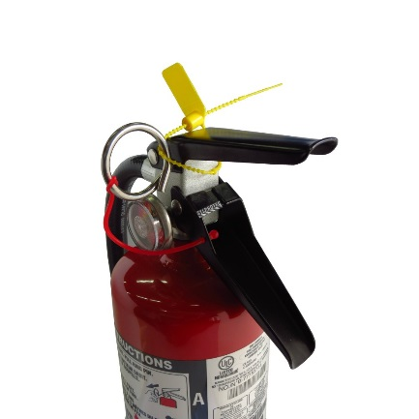
- Perform weekly inspections of fire extinguishers; ensure that:
Tamper Seal
Pin

  - The extinguisher is in the correct location
  - It doesn’t appear damaged (e.g. dents or corroded body)
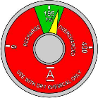
  - The Pin and Tamper Seal are in place
Indicator Gauge
  - The indicator gauge, when present, is in the green segment
  - There is no sign of discharge
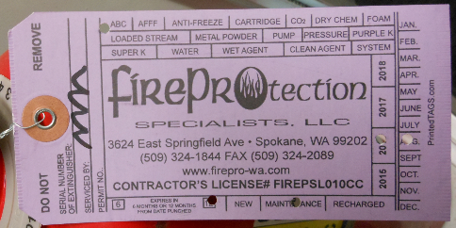
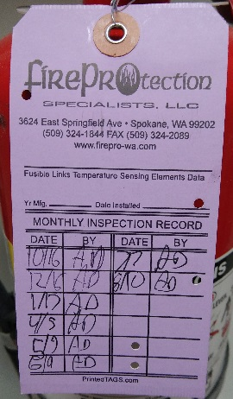
- For the first inspection of every month, sign the Inspection Card on the extinguisher.
Inspection Card, front and back
- Report any damage, discharge, defects, or missing extinguishers promptly to the Work Order Desk at 359-2245.

If you have any questions, contact the Fire Protection Engineer at 359-4576 or Environmental Health and Safety at 359-6496.

_________________ / ____________ Inspected
Month Year
Location & Extinguisher Type | Initial | Date | Initial | Date | Initial | Date | Initial | Date
Send completed forms to: Fire Protection Engineer, ROZ 101
or email: mlunneborg@ewu.edu

