Literature Circles Using The Absolutely True Diary of a Part-Time Indian
Lori Perreault

In this 2-3 week time period in 8th grade ELA, students who have selected the title The Absolutely True Diary of a Part-Time Indian will work together to identify essential questions, develop background knowledge, read independently, conduct academic discussions, and think analytically.

Part 1
Working in groups of 4-6 students will to complete a Taba concept development map using either the concept of RESOURCES or POVERTY. This method is useful to get students to focus on one particular concept and discover what essential questions they can create to guide their learning. (Group charts will vary, as will the guiding questions the groups use to proceed through the unit.)
This is an example of a Taba model using the concept of Rejection that might be useful.
Rejection
Examples of rejection:  - break up  - allergic reaction  - negative  - dissed  - hatred | Non examples of rejection:  - symbiosis  - acceptance  - love  - approval  - agreement
Therefore: (based on the patterns you see in examples and non-examples what are some generalizations that are true most or all of the time)  - Rejection can be painful  - Rejection usually involves more than one person  - Rejection is the result of an interaction  - Rejection causes a crossroads to appear | Essential Questions: (now turn those generalizations into questions)  - Why is rejection painful?  - What would happen if there were no rejections?  - How would  - How is  - Why are

Resources (or Poverty)
Examples of resources: | Non examples of resources:
Therefore: (based on the patterns you see in examples and non-examples what are some generalizations that are true most or all of the time) | Essential Questions: (now turn those generalizations into questions – with scaffolding stems)  - Why is  - What would happen if  - How would  - How is  - Why are

Part 2 – Author Biography
Spend _____ minutes reading through Sherman Alexie’s website: www.fallsapart.com.
Practice summary and response: In notebooks list 10 facts about Alexie and 5 things that surprise you or that you find interesting. (What is important to this author? What is important to know about this author?)

Part 3 – Visual entry
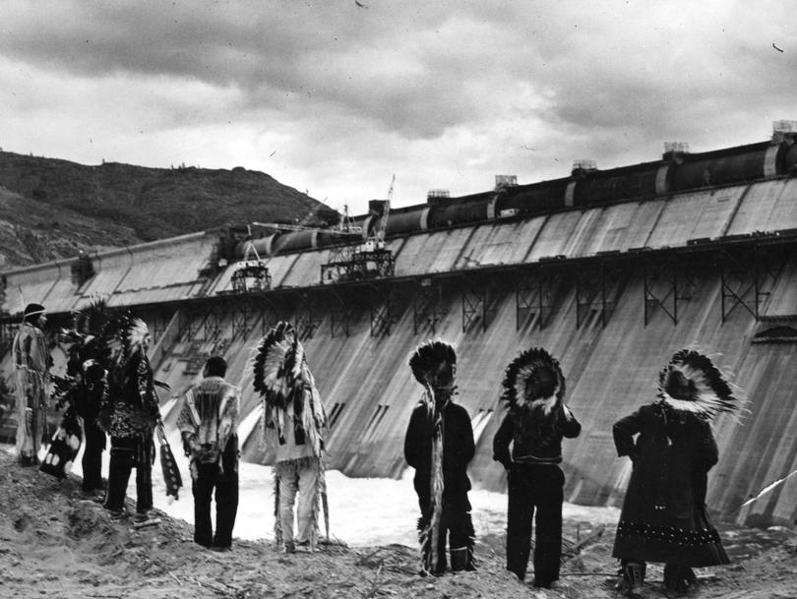
Display photo :

In groups complete an analysis which would include:
- What is the subject of the photograph? What does the photograph reveal about its subject?
- Describe is the setting for the photograph? What details do you notice that give you an indication of time and place?
- What is the message of the photo?
- How would you describe the photographer’s point of view?
Part 4 – Literature Circles – The Absolutely True Diary of a Part-Time Indian
Students will be working in a group of 4-6 students as they complete reading and discussion as it pertains to the book they have selected. Other groups in the classroom will likely be reading a different text based on students’ voice and choice.
Group members will divide the text into 6 chunks of reading. Due dates will be calendared and group members will complete reading and tasks by the designated time. Class time will be used for reporting back of individual tasks and completion of discussion led by the student completing the role of Discussion Director.
Roles may include:
Literary Luminary: Locate and notate quotes, create plot chart, cite passages that support the “big ideas” of the story.
Connector: Find connections between the book you are reading and the outside world: this could be a connection with yourself, your school, other things that you have read or seen, your community, or other situations in the world.
Research Captain: Identify a research questions that arises in the course of the reading. Uses technology to prepare 2-3 minute presentation to the small group.
Meeting of the Minds: Document conflicts between characters and identify or suggest resolutions.
Discussion Director: Prepare questions for discussion that include “big ideas,” ethical issues, character’s actions. Students should be instructed to refer back to the essential questions that they created at the first meeting.

Part 5 – Comparative readings
Students will read the following and identify the narrative in each. This could be designed as a cold read summative assessment.
- “Address at the Dedication of the Grand Coulee Dam” by Harry S. Truman
- “God Damn, God Dam” from You Don’t Have to Say You Love Me: A Memoir by Sherman Alexie

Part 6 – Student independent book project.
Students will select a method (essay, presentation, display, Chautauqua, etc.) which the student feels will address the essential questions determined by the group.

