US History
Great Depression/New Deal Unit
Learning Target
I can discuss how desperation during the Great Depression led to acts of discrimination in America.

Activity
Emphasizing causes and aftereffects lecture on:
Grand Coulee Dam
Mexican Deportation
Discrimination of Blacks

Assessment
Essay:
Using specific examples, explain how desperation during the Great Depression led to acts of discrimination in America.

Civics
Basic Civil Rights Unit
Learning Targets
I can discuss how a democratic society balances the rights of one individual against those of another.
I can discuss how a democratic society weighs the needs of the many against the needs of the few.

Activity
After lessons on First Amendment rights and how we balance the rights of one individual against another’s
Lecture on historical events related to the building of Grand Coulee Dam.
- How the environment influenced events
- Economic situation of nation and region when the dam was being proposed
- Political processes
- Perspectives of different stakeholders when the dam was proposed
- Social, economic, short-term and long-term outcomes of the dam
Read primary documents for and against the dam.

Assessment
Using the creation of Grand Coulee Dam as an example, complete two of the following using specific examples plus textual evidence from your readings:

- Discuss what a democratic society can do to balance the needs of the many against the needs of the few.

- Examine whether or not a democratic system should balance the needs of the many against the needs of the few.

- Discuss what are the strengths and weaknesses of a democratic society when it comes to balancing one person’s rights against another’s.

- Discuss how the lessons of Grand Coulee Dam can be applied to a similar present-day issue.

English
Perspectives Unit
Learning Targets
I can analyze different perspectives on a historical event.
I can analyze how Grand Coulee Dam affects my life.

Building Background
Watch clips from American Experience’s Grand Coulee Dam alternating with primary and secondary articles which present different opinions on the building of the dam.
Discuss the topics listed above in “Civics” section.

First Activity
Select a photo of the building of the dam (see example below). Write narratives from three different contemporary perspectives describing what is happening in the selected photo. Create a visual display that includes the photo and narratives.

Second Activity
Interview two people over the age of 60. Find out how the Grand Coulee Dam has affected their lives. Using quotations from the interviews, write a newspaper article explaining their perspectives. All articles will be collected and published as a pamphlet to be handed out at the community night.

Third Activity
Take photos of how the dam has affected your life. Using the photos create a visual display. Include captions that explain how each photo represents an effect the dam has on you.

Finale
All visual displays will be presented in a gallery walk format at community night with students acting as docents.
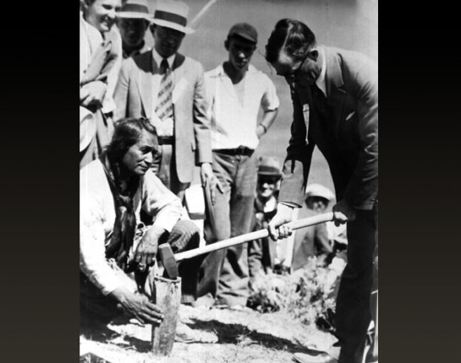
San Poil Chief Jim James and Governor Clarence Martin at a ceremony commemorating the start of construction on Grand Coulee Dam.

