To Dam or Not To Dam Rhonda Koppelmann

Objective: Students will show understanding of the impact of human actions upon the geography of the land in which the inhabit, and defend that position with logical reasoning.

Common Core:
CCSS.ELA-LITERACY.RH.6-8.6
Identify aspects of a text that reveal an author's point of view or purpose (e.g., loaded language, inclusion or avoidance of particular facts).
CCSS.ELA-LITERACY.RH.6-8.8
Distinguish among fact, opinion, and reasoned judgment in a text.
MO Standards:
4 B. Understanding the consequences of personal and public economic decisions
4 F. Interpreting the past, explaining the present and predicting the future of economic decisions
5 A. Understanding the concept of place
5 E. Understanding relationships between and among places
5 F. Understanding relationships between and among regions
5 I. Human Environment interactions
5 J. Using geography to interpret, explain and plan for the future

Anticipatory Set

Governments have the “right” to alter the land in the name of progress.

Activity -
Statement presented in class - students choose their position -- and stand in the area of the scale presented in the front of the room.

Strongly Disagree Neutral Agree Strongly
Disagree Agree
|-------------------------| -----------------------|---------------------|-----------------------|

Discussion - allow individuals to support their positions and share opinions

Purpose of Dams -- Possibilities - show one clip to generate student ideas

https://www.youtube.com/watch?v=i6ey-8jfDDI
https://www.youtube.com/watch?v=emWY6KEhCCc
https://www.youtube.com/watch?v=79EmObujA58

Categorizing Activity -- each student given 2 slips of paper of same colored paper

- Write one reason to build a dam on each strip of paper

Place students in groups - instruct them to categorize their responses (students are allowed to create their own broad categories) -- Place the name of their categories (or headings) on different colored paper than used previously - place their written responses under their chosen categories

Discussion of how and why they formed their categories - Class then votes of the top 3 reasons for the construction of dams -- Results placed on large paper or whiteboards to be used later in the lesson plan - placed in varied locations within the classroom as three separate stations

Complicating the Issue -- Pros and Cons for Dams

Use a collection of documents (primary and secondary) - some supporting the formation of dams, others arguing against the formation of dams -- students do not get to choose their position. Teacher will advise that each student is about to receive an article either supporting or opposing the formation of dams. The student’ task is to read the article through once to determine what side the article supports. Once determined, the students will read again to choose three key phrases that support the opinion of the author of the article. (Student does not get to choose their side at this point - student must work on side the article supports.)

Links to documents to possible documentation to use ….

The Colville Indians. (n.d.). Retrieved July 26, 2017, from http://www.pbs.org/wgbh/americanexperience/features/coulee-colville/

-- PBS The Colville Indians
describes what happened to the Colville Natives as a result of the dam (con)
_______________________________________________________________________
Effects of Dams and Impoundments on Migrations of Juvenile Chinook Salmon and Steelhead from the Snake River, 1966 to 1975. (n.d.). Retrieved July 26, 2017, from http://afs.tandfonline.com/doi/abs/10.1577/1548-8659(1979)1082.0.CO;2

- American Fisheries Society Effects of Dams and Impoundments on Migrations of Juvenile Chinook Salmon and Steelhead from the Snake River, 1966 to 1975 (Con) _________________________________________________________________________
Benefits of Dams. (n.d.). Retrieved July 26, 2017, from https://www.fema.gov/benefits-dams
FEMA Benefits of Dams (Pro)
____________________________________________________________________________
https://www.tva.com/Energy/Our-Power-System/Hydroelectric
Tennessee Valley Authority - HydroElectric (Pro)
______________________________________________________________________________

American Experience: Grand Coulee Dam. (n.d.). Retrieved July 26, 2017, from http://interactive.wxxi.org/highlights/2017/04/american-experience-grand-coulee-dam

PBS Go Public website -- Highlight Grand Coulee Project as part of the New Deal Project (pro) ______________________________________________________________________________
Higher Learners:
Hetch Hetchy Environmental Debates. (n.d.). Retrieved July 26, 2017, from https://www.archives.gov/legislative/features/hetch-hetchy/merced.html
- Primary source Hetch Hetchy Environmental Debates from National Archives Protest Against Diversion of Waters from Lands Requiring Irrigation from Citizens of Merced and Stanislaus Counties, California (Con)

Hetch Hetchy Environmental Debates. (n.d.). Retrieved July 26, 2017, from https://www.archives.gov/legislative/features/hetch-hetchy/merced.html

S. 151 - Reclamation Authorization Act of 1975 - memo to white house to undertake four water source projects (Pro)
______________________________________________________________________________
Struggling learners -- for those struggling readers visuals can be replaced and students can create a phrase to explain how the dam may have been interpreted by the subjects of the photos

Con: Before the Dam/After the Dam

Celilo Fall Before the Dam
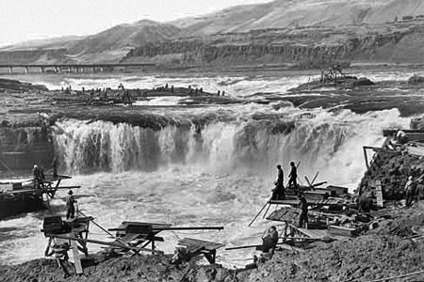
Restoring Celilo Falls. (2012, July 12). Retrieved July 26, 2017, from https://wyeastblog.org/2009/02/14/restoring-celilo-falls/

After the dam
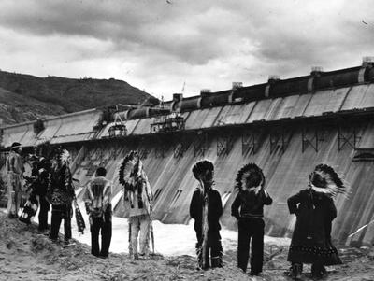
Restoring Celilo Falls. (2012, July 12). Retrieved July 26, 2017, from https://wyeastblog.org/2009/02/14/restoring-celilo-falls/

Pro
Grant County - Before Construction of Dam
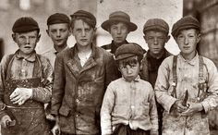

Garland J. Tutwillow - Donald Trump Supporter. (2015, July 31). Retrieved July 26, 2017, from http://iseethefrog.com/garland-j-tutwillow-donald-trump/

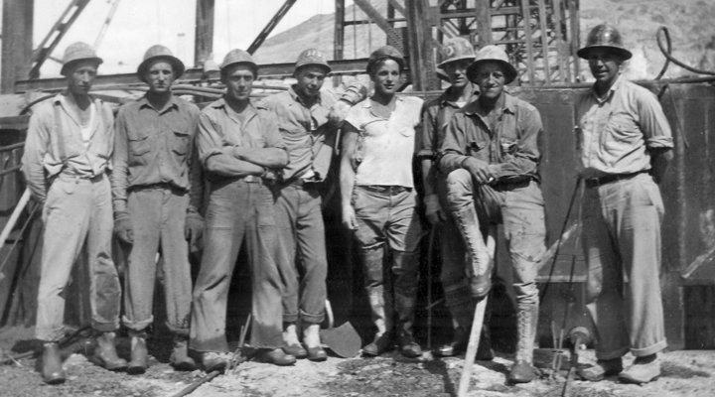
American Experience: Grand Coulee Dam. (n.d.). Retrieved July 26, 2017, from http://interactive.wxxi.org/highlights/2017/04/american-experience-grand-coulee-dam

Students then form two lines - one of those who had articles that supported the construction of dams. The second of those who articles that opposed the construction of dams.

Round 1 -- Line one - no talking, no discussion at this point

Student 1 reads aloud one phrase chosen from their reading
Student 2 reads aloud one phrase choose from their reading
Student 3,4, etc.
Once all statements read -- students given a choice to “switch lines”

Round 2 -- students who received the opposing position must then use the same process and students given the choice to move once again.

Once completed students divide themselves into those opposing and those supporting the construction of dams -- From here -- students will choose “expert teams” who will represent the main group’s opinion at one of the 3 top category stations chosen previously in class. -- These board/paper will presented in a T-chart fashion and students will place their justification under the appropriate category --

Possible example
Reason for Dam: Recreation

Pro | Con
- Economic benefit for community  - Entertainment for community  - Jobs created  - Electricity for community  - Promotes advancement in technology | - Restricts salmon reproduction  - Displaced citizens  - Activities or tourist area, not always welcome into community  - Alters natural beauty  - Contaminated streams

Revisit the original Question…..
Governments have the “right” to alter the land in the name of progress.

Discussion to follow
Did you change your mind? (If not - OK) What changed your mind? -- What topics had you not considered before lesson?

Create - Putting it to use:

In my area, a project was proposed to dam local river -- Teacher will bring this subject up and instruct students to create poster in support or opposition to this proposed project (In other areas, teacher can propose a project that is place based to their location)

Scoring Guide for Project
Poster is ... | 10 - Awesome | 8 - Good | 5 - More Needed | 3 - Missing
Creative, attractive, colorful - Well thought out
A clear representative of student’s position
Clearly supported with 3 logical reasons for student position
A product of a student who stayed on task and used time wisely

