Timesheet Information
- Only enter actual hours worked; falsifying a timesheet is grounds for termination
- Pay periods are the 1st – 15th and the 16th – end of the month
- Timesheets must be submitted and approved by the “Web Timesheet Deadline” (see below)
- Timesheets must be approved by the timesheet approver

Logging Worked Hours
- Go to https://inside.ewu.edu/
- Click on the “Employees” tab at the top right of the screen, a drop down menu will be displayed
- Click on “Timesheets for Staff and Students” under the “Employment” section located in the left column of the page.
- Log in with your EWU Net ID and password; if you do not know your EWU Net ID and/or password, follow the instructions on the sign-on page to obtain or reset it.
- Select “Timesheet” (you will see Employee Dashboard /Timesheet), the pay period dates will appear.
- Then select “Start Timesheet” for the current pay period.
  - If you have more than one on-campus position, you will need to select the position that you are entering hours for according to the title, department, budget number, or position number.
  - Please note that although you may only hold one position, there can be more than one timesheet due to different budget numbers specified by your supervisor. In this case, please contact your supervisor to verify which hours to log on which timesheet.
- In your timesheet, you will be able to view your Title and Number, Department and Number, Time Sheet Period, and Submit By date. Please verify that these are correct before entering your timesheet.
- Select the day of the week on the calendar you want to add hours to, then select the start time that pops up. You must select the clock in the right-hand corner and scroll with your mouse or arrows on your keyboard to the time of the day and for am/pm to enter the hours worked on the specific date. Then select “set” and move to the leave time.
  - Remember to exclude lunch breaks (required when working over 5 hours in a shift).
    - Select “+ Add More Time” to add hours when taking a lunch break.
  - Shifts should be entered at intervals of 15 minutes in the 00:00 format (i.e. 10:00, 10:15, 10:30, 10:45.)
  - Click the “Save” button before you leave the page or submit your timesheet.
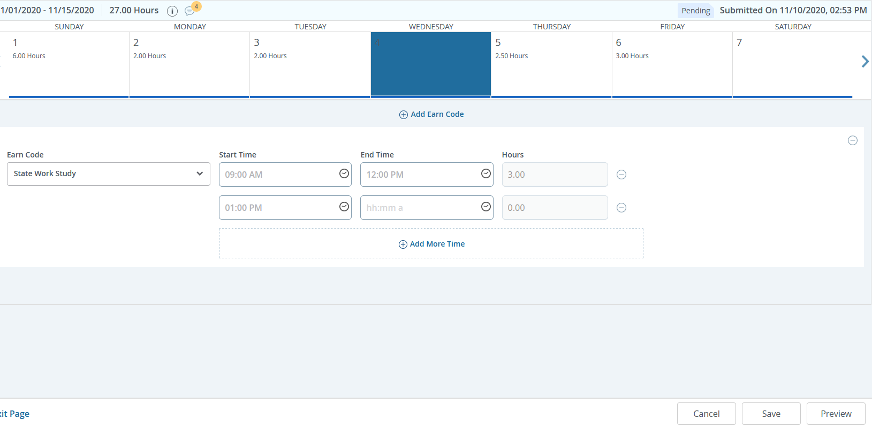
- When taking sick leave, see “Leave Balances in the top right-hand corner. To enter sick leave, go to the calendar date then select “+Add Earn Code” in the middle of the page under the calendar. Use the arrow key and select “sick leave”
- On the last day worked of the pay period, verify that the hours on the timesheet are correct and select “Preview” button in the right-hand corner.
- The “Submit” button comes up and then select to send your timesheet to your timesheet approver.
- Your timesheet should show as Pending.
- Your timesheet approver will verify that the hours reported are correct and approve your timesheet. It is then automatically routed to Payroll who will generate your pay check.
- You are unable to enter hours once the “Web Timesheet Deadline” has been reached. In this case, you will need to fill out a paper timesheet, get it approved and signed by your timesheet approver, and turned into Payroll.

Employee Dashboard
You are now able to change your address in your profile in your Dashboard.

- Select “Employee Dashboard”
- Select “My Profile”
- Select the pen on the right-hand side of the page, the page opens to edit your profile.
- Select the portion of your profile you would like to select, by clicking your mouse on the pen “edit” next to the section you want to correct.
- You will see your “Mailing Address” and “Permanent Address”. Your check will go to your “Mailing Address”. Please make sure you select the right address to change.

